11th Annual U. S. Air Force Academy
Candidate Orientation Program
Presented by the
U. S. Air Force Academy Georgia Parents Club
U. S. Air Force Academy Admissions Liaison Officers (ALOs)

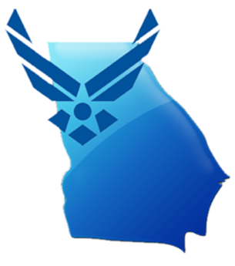
Saturday, December 27th, 2014
10:00 AM to 12:00 noon

American Legion Post 160
160 Legion Drive SE
Smyrna, GA 30080

Engineers . . . . Pilots . . . . Scientists

Who: All interested high school students and their parents

Why: Meet one-on-one with current Air Force Academy cadets, their parents, and Academy Liaison Officers. Find out what Academy life is really like. Ask your questions about academic majors, military training, clubs, and sports. This event is FREE to attend.

This is a “can’t miss” opportunity to gain firsthand knowledge and help yourself in preparation for the road ahead. You do not need to RSVP to attend, but we would appreciate knowing for planning purposes. Please respond to Tsali Bentley at tdbentle@southernco.com to help us plan for the event.

Tsali Bentley
Georgia Air Force Academy Parents Club
tdbentle@southernco.com or (706) 745-2662

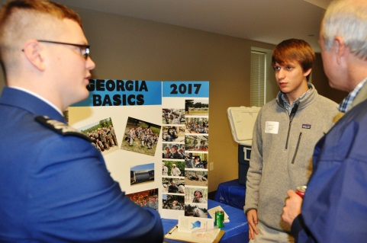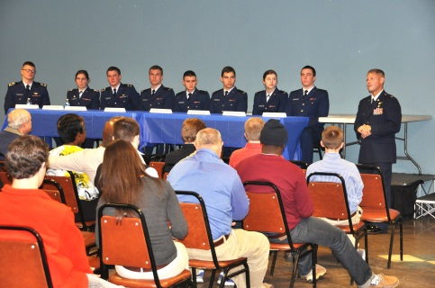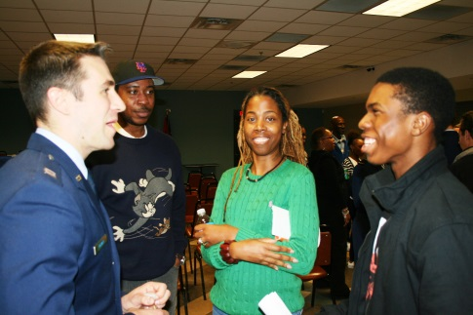

This is not an offical publication of the U.S. Air Force Academy or the U.S. Air Force.

